Ques) what do you mean by spring frame work?

The Spring Framework is a comprehensive framework for enterprise Java development. It provides a wide range of features and functionalities to simplify the development of Java applications, particularly in the realm of enterprise-level, scalable, and modular applications.

Key features of the Spring Framework include:

* 1. Inversion of Control (IoC): This is a design principle where the control flow of a program is inverted. In the context of Spring, it means that the framework manages the objects of your application, creating and injecting dependencies.
  2. Dependency Injection (DI): This is a specific type of IoC where the dependencies of a class are injected from the outside rather than created within the class. Spring handles this through configuration files or annotations, making it easier to manage and test components.
  3. Aspect-Oriented Programming (AOP): AOP allows you to separate cross-cutting concerns like logging, security, and transaction management from your core business logic. Spring provides a way to define aspects and apply them to specific parts of your application.
  4. Data Access: Spring simplifies database access using JDBC and provides high-level abstractions for working with various data sources, including Object-Relational Mapping (ORM) support with frameworks like Hibernate.
  5. Transaction Management: Spring provides a consistent programming model for managing transactions across different transactional resources, such as databases and message queues.
  6. Model-View-Controller (MVC): Spring MVC is a web module that facilitates the development of web applications following the MVC design pattern. It provides a powerful and flexible way to build web applications.
  7. Security: Spring Security is a module that provides comprehensive security services for Java EE-based enterprise software applications.
  8. Containerization: Spring can be used as an IoC container, managing the lifecycle of Java objects and wiring them together based on configuration.
  9. Simplifying Java EE development: Spring simplifies many aspects of Java EE development, making it more lightweight and developer-friendly.

The Spring Framework is modular, allowing developers to use only the components they need. It promotes a modular and flexible architecture, making it suitable for a wide range of applications from small-scale projects to large-scale enterprise systems.



QUES) The general philosophy and approach of the Spring Framework?

The principles you've listed align with the general philosophy and approach of the Spring Framework. Let's delve a bit deeper into each principle:

* 1. Provide choice at every level:
     + Spring is designed to be highly modular, allowing developers to choose the components they need for their applications. This flexibility extends from the core container to various modules like data access, security, and web frameworks. Developers can opt for the parts of the framework that best suit their requirements.
  2. Accommodate diverse perspectives:
     + Spring acknowledges that different projects and teams may have diverse requirements and perspectives. It provides a broad range of features and functionalities, making it suitable for a variety of application types, from small projects to large enterprise systems. This inclusivity allows developers to adopt the parts of the framework that align with their specific needs.
  3. Maintain strong backward compatibility:
     + Backward compatibility is a key consideration in Spring's evolution. The framework strives to ensure that newer versions do not break existing applications built on older versions. This commitment to backward compatibility helps in smooth transitions and allows developers to adopt newer features without significant rewrites.
  4. Care about API design:
     + Spring emphasizes the importance of well-designed and consistent APIs. A clear and intuitive API design makes it easier for developers to understand and use the framework effectively. It also contributes to a positive developer experience, as intuitive APIs reduce the learning curve and enhance productivity.
  5. Set high standards for code quality:
     + Maintaining high standards for code quality is a fundamental principle in the Spring community. The framework is developed with a focus on clean, readable, and maintainable code. This commitment to code quality not only improves the framework itself but also sets an example for developers using Spring to follow similar practices in their applications.

By adhering to these principles, the Spring Framework has become a popular choice for Java developers seeking a flexible, modular, and reliable solution for building a wide range of applications. These principles contribute to the framework's success in addressing the evolving needs of the Java development community.



QUES) briefly explain spring architecture?

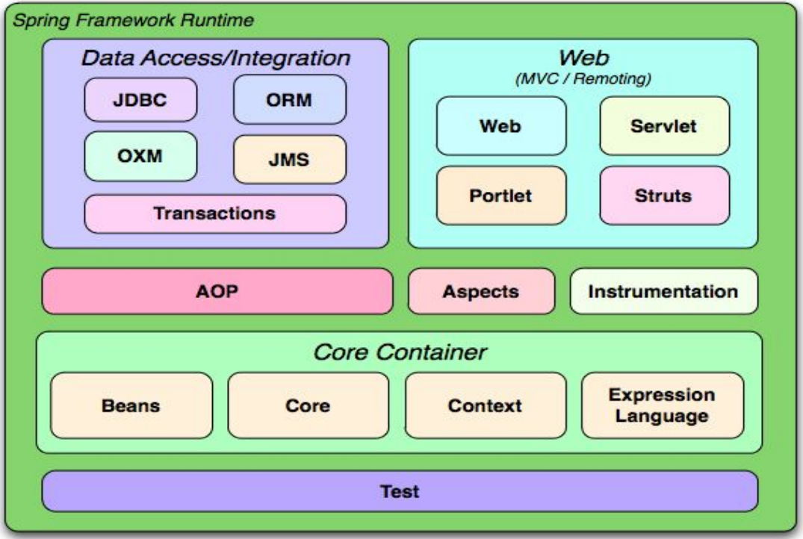

The Spring Framework follows a modular and layered architecture, providing a comprehensive infrastructure for developing Java applications. The architecture is designed to be flexible, scalable, and easily extensible. Here's a brief overview of the key components in the Spring architecture:

* 1. Core Container:
     + The core container is the foundation of the Spring Framework and includes the following modules:
       - Beans: Handles the instantiation and management of Java objects (beans). It supports configuration through XML, Java annotations, or Java code.
       - Core: Provides fundamental features like the IoC container and the BeanFactory interface.
       - Context: Builds on the core container and adds features like event propagation, resource loading, and application context initialization. The ApplicationContext is a central interface in this module.
  2. Data Access Layer:
     + The data access layer simplifies database operations and interactions. Key modules include:
       - JDBC (Java Database Connectivity): Simplifies database access using JDBC and provides error handling and connection management.
       - ORM (Object-Relational Mapping): Integrates with popular ORM frameworks like Hibernate, JPA (Java Persistence API), and MyBatis.
  3. Transaction Management:
     + Manages transactions in a consistent and flexible manner, supporting both programmatic and declarative transaction management.
  4. Model-View-Controller (MVC):
     + The Spring MVC framework provides a robust and flexible way to develop web applications following the MVC design pattern. It includes components for handling requests, managing views, and implementing controllers.
  5. Security:
     + The Spring Security module provides comprehensive security services for Java applications. It covers authentication, authorization, and protection against common security vulnerabilities.
  6. Aspect-Oriented Programming (AOP):
     + The AOP module allows developers to separate cross-cutting concerns from the core business logic. It provides a way to define aspects that encapsulate these concerns and apply them to specific parts of the application.
  7. Instrumentation:
     + The instrumentation module supports class instrumentation and class loading in a Java Virtual Machine (JVM) environment, enabling advanced features like monitoring and profiling.
  8. Messaging:
     + The messaging module simplifies integration with messaging systems, supporting both point-to-point and publish-subscribe communication.
  9. Web:
     + The web module includes features for building web applications, including Spring Web MVC, which facilitates the development of web controllers and views.
  10. Test:
      + The test module provides support for unit testing and integration testing of Spring components.

The Spring architecture is designed to be modular, allowing developers to use specific components based on their application's requirements. The layered approach and modular design contribute to the framework's flexibility, making it suitable for a wide range of enterprise application scenarios.

QUES)

1. Briefly explain about inversion of control?
2. By what name it is also known as?
3. Task perform by IOC?
4. Types of Spring IOC Container?
5. Syntax?

Ans)

(i)

. Spring Framework implementation of the Inversion of Control (IoC) principle.

. Spring IoC container is responsible for create, wire, configure and manage objects during their complete life cycle. It uses configuration metadata for create, configure and manage objects. Configuration metadata can be represented by spring configuration xml file or annotations.

(ii)

. IoC is also known as dependency injection (DI).

– It is a process whereby objects define their dependencies (that is, the other objects they work with) only through constructor arguments, arguments to a factory method, or properties that are set on the object instance after it is constructed or returned from a factory method.

– The container then injects those dependencies when it creates the bean.

– This process is fundamentally the inverse (hence the name, Inversion of Control) of the bean itself controlling the instantiation or location of its dependencies by using direct construction of classes or a mechanism such as the Service Locator pattern.

(iii)

Inversion of Control (IoC) is a key concept in the Spring Framework, and it performs several tasks to manage the flow of control in an application:

* 1. Create Objects:
     + IoC is responsible for creating and instantiating objects, often referred to as beans, defined in the application context.
  2. Manage Lifecycle of Objects:
     + IoC container manages the complete lifecycle of beans, handling their initialization, usage, and, if needed, destruction.
  3. Inject Dependencies to Our Classes:
     + IoC enables dependency injection, injecting dependencies into the classes rather than having the classes create or look up their dependencies. This promotes loose coupling and easier maintenance.
  4. Bean Factory Interface:
     + The BeanFactory interface, a core part of IoC, defines a contract for creating and managing beans. It serves as the foundation for more advanced container implementations like the ApplicationContext.
  5. Application Context Interface:

The ApplicationContext interface extends BeanFactory and provides additional functionalities for application-level context, such as event propagation, resource loading, and more.

1. ClassPathXmlApplicationContext:

An implementation of ApplicationContext that loads the context definition from an XML file located in the classpath. It is commonly used for standalone applications.

1. FileSystemXmlApplicationContext:

Another implementation of ApplicationContext that loads the context definition from an XML file specified as a file system path. It is useful in scenarios where the application context configuration is not within the classpath.

* 1. Singleton Management:
     + IoC manages the singleton scope of beans, ensuring that a single instance of a bean is shared across the application context.
  2. Configuration Management:
     + IoC handles the configuration of beans, allowing developers to define bean properties, dependencies, and other settings through XML configuration files, Java annotations, or Java code.
  3. Aspect Integration:
     + IoC integrates with the Aspect-Oriented Programming (AOP) module, allowing the application to apply aspects (cross-cutting concerns) to the objects managed by the IoC container.
  4. Event Handling:
     + IoC container supports the publishing and handling of events. Components can publish events, and other components can listen for and respond to these events.
  5. Resource Management:
     + IoC can manage resources such as databases, JNDI (Java Naming and Directory Interface) objects, and messaging resources, making it easier to access and utilize these resources in the application.
  6. Annotation Support:
     + IoC supports annotations for bean configuration, allowing developers to use annotations like @Component, @Autowired, and others to define and inject beans.
  7. Customization and Extension:
     + IoC allows for customization and extension through various hooks and interfaces, enabling developers to integrate their own functionality into the container's lifecycle.

(iv)

Types of Spring IoC container:

**1. BeanFactory**

**2. ApplicationContext**

## BeanFactory:

BeanFactory org.springframework.beans.factory.BeanFactory is the interface and XmlBeanFactory is an implementation class of it. It is a simple container which provides the basic support for dependency injection.

**Syntax to use BeanFactory:**

|  |
| --- |
| **Resource resource = new ClassPathResource(“spring configuration file”);**  **BeanFactory beanFactory = new XmlBeanFactory(resource);** |

ApplicationContext:

ApplicationContext org.springframework.context.ApplicationContext is the interface and ClassPathXmlApplicationContext is an implementation class of it. ApplicationContext container includes all functionality of the BeanFactory container with some extra functionality like internationalization, event listeners etc.

**Syntax to use ApplicationContext:**

|  |
| --- |
| **ApplicationContext applicationContext =**  **new ClassPathXmlApplicationContext("spring configuration file");** |

**Note: As ApplicationContext provides extra functionality including all given by BeanFactory it is better to use ApplicationContext container.**

QUES) Write a short note on org.springframework.context.ApplicationContext?

Ans)

The org.springframework.context.ApplicationContext interface is a fundamental component in the Spring Framework, serving as the Inversion of Control (IoC) container. Its primary role is to manage the instantiation, configuration, and assembly of beans within a Spring application. Beans are objects that form the backbone of the application and are managed by the Spring IoC container.

Key features of the ApplicationContext interface include:

1. Bean Management: The container is responsible for creating and managing beans. It instantiates the objects, configures them based on specified metadata, and assembles them as required.
2. Configuration Metadata: The container relies on configuration metadata to understand how to create and wire beans. This metadata can be provided in various forms such as XML files, Java annotations, or even Java code. These configurations define the structure of the application and the relationships between its components.
3. Flexibility in Configuration: Spring allows developers to express configurations in multiple ways, providing flexibility. Whether using XML files for traditional configuration, annotations for a more concise approach, or Java code for a programmatic setup, developers can choose the most suitable method for their needs.
4. Rich Interdependencies: The ApplicationContext enables developers to express rich interdependencies between objects. This means that developers can define relationships and collaborations between beans, facilitating a loosely coupled and modular design.

In summary, the org.springframework.context.ApplicationContext interface plays a central role in the Spring Framework's IoC container. It interprets configuration metadata, which can be specified in XML, annotations, or Java code, to instantiate, configure, and assemble beans, allowing developers to articulate the structure and interdependencies of their applications. This abstraction promotes a modular and maintainable design by promoting loose coupling between components.

QUES) write a short note ApplicationContext interface?

Ans)

The ApplicationContext interface in the Spring Framework serves as the core container for managing beans in a Spring application. In stand-alone applications, two commonly used implementations of this interface are ClassPathXmlApplicationContext and FileSystemXmlApplicationContext.

1. ClassPathXmlApplicationContext:
   * This implementation is used when the configuration metadata is specified in XML format and is located on the classpath. It loads the XML file and configures the application context accordingly, instantiating and managing the defined beans.
2. FileSystemXmlApplicationContext:
   * Similar to ClassPathXmlApplicationContext, this implementation is employed when configuration metadata is provided in XML format, but in this case, the XML file is located in the file system. It allows for flexibility in configuration file location, especially in scenarios where the XML file is not within the classpath.

While XML has traditionally been the preferred format for defining configuration metadata, the Spring Framework provides the flexibility to use Java annotations or code for configuration. Developers can instruct the container to recognize and process annotations or code as metadata formats by providing a small amount of XML configuration. This declarative approach enables the support for additional metadata formats without having to extensively modify the application's structure.

In summary, the ApplicationContext interface, along with its various implementations like ClassPathXmlApplicationContext and FileSystemXmlApplicationContext, forms the backbone of bean management in stand-alone Spring applications. The ability to switch between XML, annotations, and Java code for configuration offers developers the freedom to choose the most suitable approach based on their preferences and project requirements.

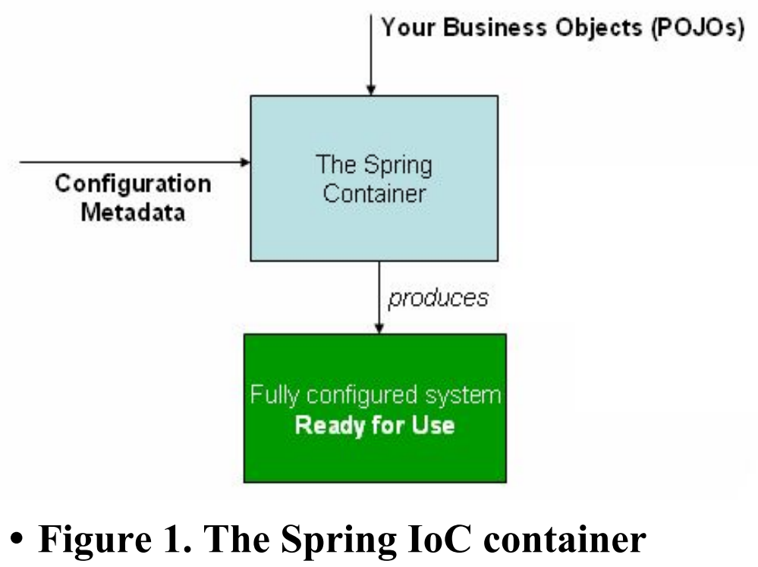

QUES) XML-based configuration metadata?

 ANS)

XML-based configuration metadata is a widely used and traditional approach in the Spring Framework for specifying how the Spring IoC container should manage beans within an application. In XML-based configuration, developers define beans, their properties, and relationships between beans using XML files. These files serve as a blueprint for the Spring container, guiding it on how to instantiate, configure, and assemble objects.

Key characteristics of XML-based configuration metadata:

* 1. Configuration File Structure:
     + The configuration is typically stored in one or more XML files.
     + The XML file follows a specific structure, containing elements that define beans, dependencies, and other configuration details.
  2. Bean Definitions:
     + Beans are defined using <bean> elements within the XML file.
     + Each <bean> element includes attributes such as id (a unique identifier for the bean) and class (specifying the class of the bean).

xmlCopy code

<beans>  
 <bean id="exampleBean" class="com.example.ExampleBean"/>  
</beans>

* 1. Bean Properties:
     + Properties of a bean, such as its attributes, are set using nested elements within the <bean> element.

xmlCopy code

<beans>  
 <bean id="exampleBean" class="com.example.ExampleBean">  
 <property name="propertyName" value="propertyValue"/>  
 </bean>  
</beans>

* 1. Bean Relationships:
     + Relationships between beans are established through references.

xmlCopy code

<beans>  
 <bean id="dependentBean" class="com.example.DependentBean"/>  
 <bean id="exampleBean" class="com.example.ExampleBean">  
 <property name="dependentBean" ref="dependentBean"/>  
 </bean>  
</beans>

* 1. XML Configuration File Loading:
     + The Spring IoC container loads and interprets the XML configuration files during application startup to create the defined beans and establish their relationships.

javaCopy code

ApplicationContext context = new ClassPathXmlApplicationContext("spring-config.xml");

* 1. Advantages and Considerations:
     + XML-based configuration provides a clear separation between application code and configuration.
     + It is human-readable and facilitates easy modification without recompilation.
     + However, it can become verbose for large configurations, and errors may only be detected at runtime.

While XML-based configuration has been a traditional and widely used approach, Spring also provides alternatives such as annotation-based and Java-based configuration for more concise and programmatic ways of expressing bean configurations. The choice between these approaches often depends on the project's requirements and the developer's preferences.

**NOTE: SEE EXAMPLE IN PPT**